

Circular no.: 2021/05 Date : 18th August, 2021

To,

All Members.

OUR SKILL DEVELOPMENT & LEARNING CENTRE's

**INAUGURATION**

The 75th Anniversary of 'Freedom of India' was made memorable by OUR 'Welfare Association' by organising a Programme for Inauguration of

**Skill Development & Learning Centre.**

On Sunday, 15 August, 2021 the function was held at OUR Book-Bank situated at the basement area of MMO building in Horniman Circle area, Fort, Mumbai.

*Dignitaries present are :*

**Mr. Madhur Kumar,**  **Mr. Vinod Nikam,**

GM, Greater Mumbai Zone. GS. All India Bank of Baroda Karmachari Sena

**Mr. Jagadish Tungaria,** **Mr. Jaywant Golatkar,**

GM. Greater Mumbai Zone President, All India Bank of Baroda Karmachari Sena

**Mr. Ravindra Agarwal,** **Mr. Pankaj Kerkar,**

GM, CFS GS. Bank of Baroda Sthaniya Lokadhikar Samiti.

**Mr. Venkat,** **Mrs. Anisha Hirlekar**

DRM, MMSR. Working President,

AIBOBKS -- Women's Wing.

**Mr. Mohapatra**

A.G.M, MMO Branch.

•••••••••••••••••••••••••••••••••••••

**The Function !**

At the outset we will would like to Thank **Shri. VINOD NIKAM (General Secretary, AIBOBKSENA ),** whose brain child our "Welfare Association" is !

He visualised, gave shape, neatly formed it and facilitated the very important guidance required. **Really a great visionary he is !**

The Programme began with Ribbon Cutting by our **Zone Heads Mr. MADHUR KUMAR and Mr. JAGDISH TUNGARIA.**

Both lit lamp in front of statue of **Bharatratna Dr. Babasaheb Ambedkar**.

**Dr. Ambedkar's topmost priority was Learning.** He wanted every citizen to Learn and keep on learning forever. This occasion was a perfect tribute to Mahamanav Dr. Ambedkar.

After inaugurating the Book Bank, Mr. Madhur Kumar advised us to start a learning centre which will develop skills of our employees.

We meticulously worked on the advise. In very short time we put the idea into practice.

He was Glad to inaugurate the same.

During the programme, our President Mrs. Sindhu Sonawane gave **brief idea on History and Purpose of OUR 'Welfare Association. Purpose and Use of "Book Bank".**

The **functioning of** **Skill Development Centre** along with it's **Future Benefits to Staff and Bank** was **impressively** explained through PowerPoint presentation by our Joint Secretary **Mr. Amey Kondvilkar.**

…2…

…2…

We even assured them that **we are going to come up with more diversified and useful activities.**

We are thankful to **Mr. Madhur Kumar and Mr. Jagdissh Tungaria G.M., Greater Mumbai Zone** for providing us premises, books, furniture, stationery, computers etc.

We are also thankful to **MMO** **executives and entire organisation of Bank Of Baroda.** Without their support and encouragement all this was not possible.

***OUR FURTHER AIMS :***

÷÷÷÷÷÷÷÷÷÷÷÷÷÷÷÷÷÷

1. TO build confidence in lower ranked and elderly staff so that they can learn to operate computers without any hesitation. This will help in spreading computer literacy among all categories of staff.
2. Those who work on computers at branches, do not find time to learn advanced features. They can also learn here.
3. We will soon start short duration Computer Learning Courses. These classes will be held on Sundays/ Holidays for the convenience of staff.
4. GM Mr. Madhur Kumar has requested us to encourage education of Girls from our employees' families. We have taken his advise seriously. We may start scholarship scheme for girls passing X & XII std exams with good marks. It may prove good incentive for them to study.
5. OUR office bearers and members have donated a few books to Book Bank. We have lent few books to staff for their study in Banking, Promotion Tests, CAIIB & JAIIB Exams. We are going to ask the book borrowers to donate at least one book each on Banking to our Book Bank. We wish to build good Library for Reference Books on Banking. Both the GM assured us of any further help required in carrying out object oriented programmes.

It was a fruitful programme.

We thank from bottoms of our heart to **All India BOB Karmachari Sena, It's Officer Wing, Women's Wing and the all important "BOB Sthaniya Lokadhikar Samiti."**

Our **PRESIDENT Smt. Sindhu Sonawane** and other **office bearers** did not leave any stone unturned to make this function memorable, attractive, useful, successful and GRAND.

Members, your support is Our strength.

Be with us.

Let us see brighter tomorrow.

Thank you ALL.

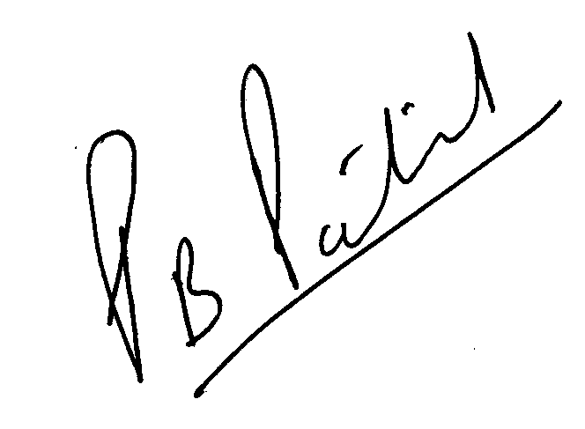

(PRASHANT PATIL)

**General Secretary**

