

Circular no.: 2021/**06** Date : 20th October, 2021

**For Information To All Members**

It was a proud and historic moment when Prime Office Bearers of Bank **of Baroda Akhil Bharat Anuschit Jati Jan Jati Employees' Parishad** joined our Welfare Association as well as Karmachari Sena.

In the two day meeting held at Mumbai on 15th & 16th October, 2021 which was attended by members from Delhi, Baroda, Jaipur, Chattisgarh and Bhopal as well there were meaningful rounds of discussion amongst Prime Office bearers of both associations.

The first day was spent in knowing each other well along with discussions on the past work done and future tasks which needs to be carried out.

On the second day, our Mentor, Philosopher & Guide Shri Vinod Nikam, General Secretary, All India Bank of Baroda Karmachari Sena addresses the meeting and shared his inputs on the vision of the association.

We are also pleased to announce that it has been unanimously decided to appoint Mr. Pramod Kumar Sahoo, Chief Manager, as Working President of our Association.

We once again whole heartedly welcome our new colleagues.

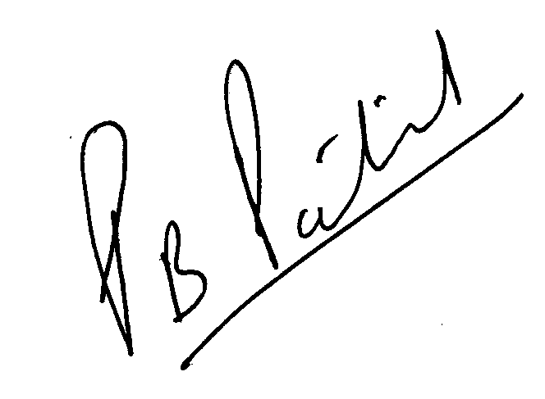Thank you

(Prashant Patil )

**General Secretary**

